**Team ID: PNT2022TMID09860**

**Project Name:** Early detection of forest fire

## PROPOSED METHODOLOGY

The flow of the proposed architecture is shown in Figure . The video input is captured from the camera, and the other inputs such as wind speed, wind directions, and IR image sensing are calculated using the sensors mounted on the UAV for navigation. These images are provided as input to the deep learning models, and it checks for the existence of the fire. The region is predicted clearly since there is a possibility of more projections of the image provided to the model due to the 3D modelling.

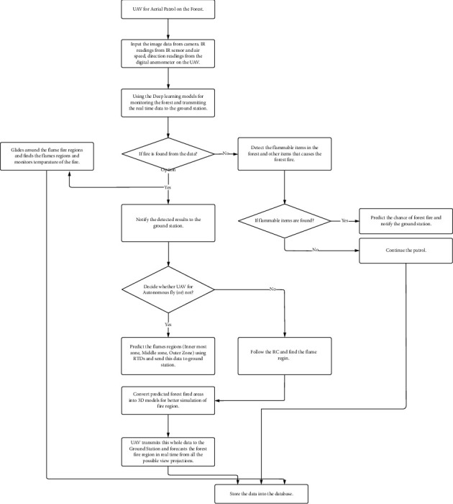

### Autonomous Drone Routing:

### Drone Moment to the Target:

In this whole operation, navigation of UAVs is significant to patrol the risk-prone areas and fire-detected areas. This work monitors the forest area with the help of the navigational analysis technique .To facilitate this, the drone makes the navigation. UAVs have the following three navigational features

1. Awareness: This provides details about UAV's neighborhood obstacles. The data is collected using internal sensors
2. Basic Navigation: Collisions are avoided, and the obstacles such as birds, trees, poles, and so on in the forest farms are detected
3. Expanded Navigation: Advanced features such as pathway planning and depth deployment are included and play a crucial role in autonomous navigation

#### Technical Information of UAV:

Flight planning is considered a salient feature in designing the architecture of UAVs . This planning illustrates the division of mass on UAVs and provides a better understanding of the performance analysis of UAVs. Specifically, maximum take-off weights (MTOW) assess the UAV payload capacity at different heights above the ground. The payload of the UAV and the mass of onboard equipment are given below and the components of the UAV are depicted . The battery used on the UAV reserves the UAV in GPS-enabled environments for 107 minutes of duration, whereas on the GPS-disabled environment, maximum flight time is 87 minutes.

**REFERENCE:** Ollero A., Arrue B. C., Martinez J. R. For reducing false alarms in forest-fires. Computer Communications S0140366419308655–*.*2019 doi: 10.1016/j.comcom.2019.10.007. [[CrossRef](https://doi.org/10.1016%2Fj.comcom.2019.10.007" \t "_blank)] [[Google Scholar](https://scholar.google.com/scholar_lookup?journal=Computer+Communications+S0140366419308655%E2%80%93&title=For+reducing+false+alarms+in+forest-fires&author=A.+Ollero&author=B.+C.+Arrue&author=J.+R.+Martinez&publication_year=2019&doi=10.1016/j.comcom.2019.10.007&)]

### 